

The Future Unemployed

The NEXT WAVE IN TECHNOlogy

February 6, 2026
Gracie Mitchell, Graham McCabe, Reid Holloway
Panther Cloud Air | Panthercloudair@gmail.com

Table of Contents
Manual Overview 4
Description 4
Installation Guide 4
Hardware and Software Requirements 4
Installation Overview 5
Installation Instructions 5
Employee User Guide 6
Administrator User Guide 7
Overview 7
Route Profit 7

Table of Figures

Figure 1: Team Logo 4
Figure : Employee Overview 9
Figure : Schedule 10
Figure : Booking 11
Figure : Selection 11
Figure : Booking confirmation 12
Figure : Admin Overview 14
Figure : Route Profit 14
Figure : Route Detail 15
Figure : Admin Fleet Page 15
Fleet Performance Table 16
Figure : Fleet Detail View 17
Figure : Simulation Control 18
Figure : Simulation Days 18
Figure : Pricing Tab 19

Table of Tables
Table 1: Cost Overview 13
Table 2: Fleet Column Table 17
Table 3: Pricing Margins 20
Table 4: Employee vs Admin Features 21



Figure 1: Team Logo

Manual Overview

Description
This manual provides a comprehensive guide for setting up and using the Panther Cloud Air (PCA) system. It covers the full installation process, including environment configuration and database setup, followed by a user guide for employees detailing how to search flights and manage bookings, and an administrator guide covering how to view route and aircraft profitability reports and update profit margins within the system.

Installation Guide

Hardware and Software Requirements
Hardware
- Model: Dell Pro 14 Premium
- Processor: Intel Core Ultra 7 268V, 2200 MHz, 8-core processor
- Memory: 32 GB of RAM
- Storage: 120 GB of available disk space
- Display: 14-inch monitor
Software
- Operating System: Microsoft Windows 11 Enterprise or equivalent
- Code Editor: Visual Studio Code or any preferred development environment
- Version Control: Git and Github
- Backend Server: Flask, deployed via Docker
- Database Management: MariaDB, deployed via Docker
- Containerization: Docker Desktop

Installation Overview
Before beginning installation, users should ensure they have Docker Desktop, Git, and a code editor such as Visual Studio Code installed on their device. The system is not limited to any specific operating system and can run on Windows, macOS, or Linux provided these prerequisites are met. Once prerequisites are in place, this section will walk through cloning the GitHub repository, environment configuration, Docker setup, Flask configuration, and database initialization to get the system up and running

Installation Instructions

Step 1: Install Prerequisites

Before setting up the Panther Cloud Air system, the following software must be installed on your device.

- Git — Download and install from https://git-scm.com/downloads. Git is required to clone the repository to your local machine.
- Docker Desktop — Download and install from https://www.docker.com/products/docker-desktop. Docker Desktop is required to run the Flask backend and MariaDB database.
- Visual Studio Code — Download and install from https://code.visualstudio.com/download. Visual Studio Code is the recommended code editor for managing and running the project, though any preferred development environment may be used.

Step 2: Clone the Repository
The repository is the folder that contains all of the files needed to run the Panther Cloud Air system. Follow the steps below to download it to your device.

- Open Visual Studio Code on your device.
- Press Ctrl + ` to open the terminal. A panel will appear at the bottom of the screen.
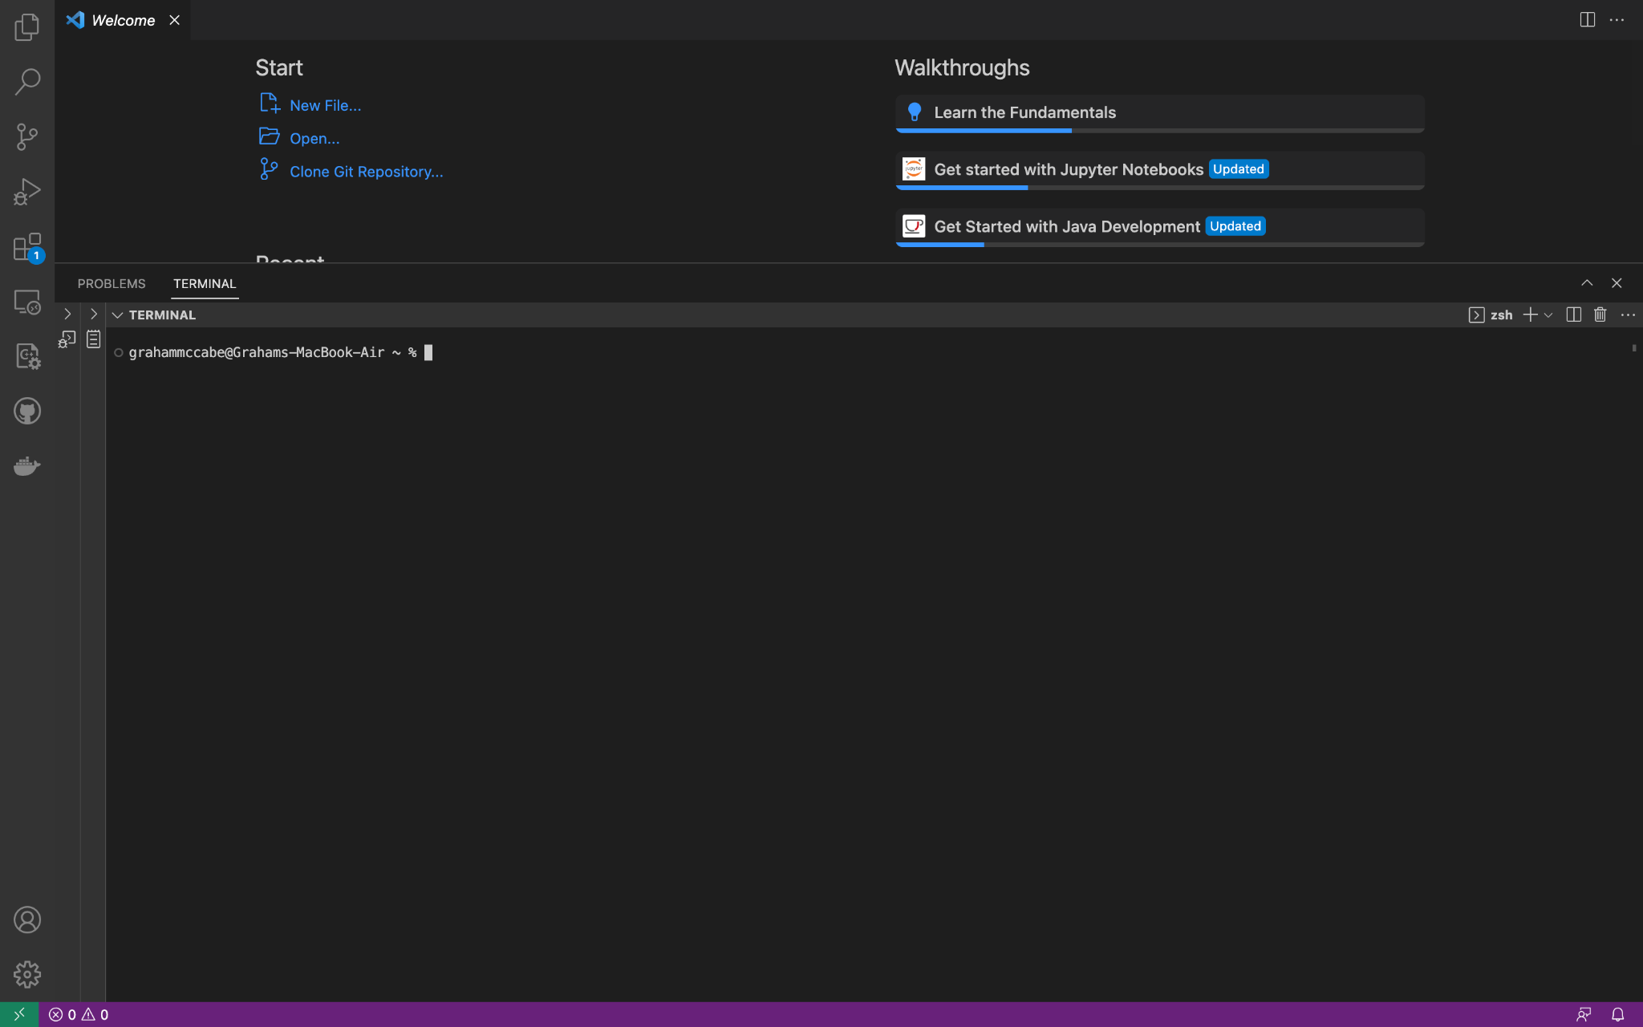

Figure 1: Opening VS Code
- In the terminal panel, type the following command and press Enter: git clone git clone https://github.com/whodja/CSC-4710-Project.git
- Once the download is complete, type the following command and press Enter to open the project folder: cd CSC-4710-Project

Step 3: Start Docker

Docker is the program that runs the backend of the Panther Cloud Air system. Follow the steps below to get it running.

- Open Docker Desktop on your device and wait for it to fully load. You will know it is ready when the icon in your taskbar stops animating.
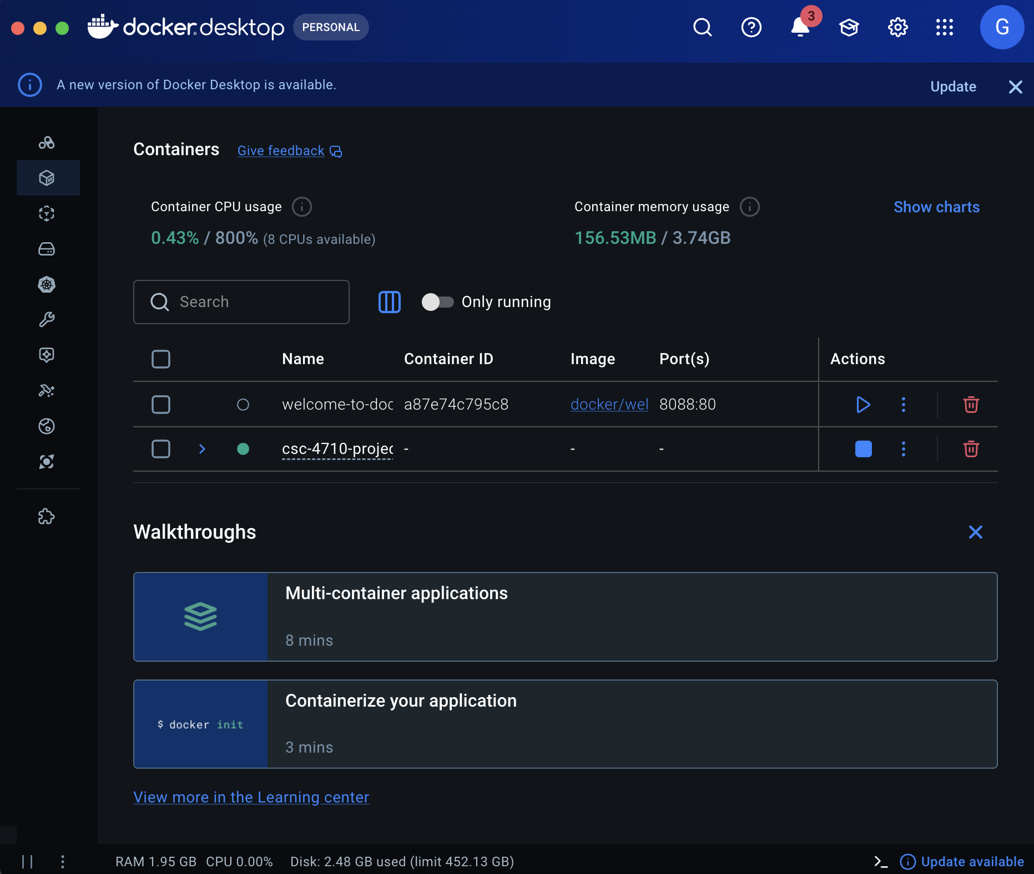

Figure 2: Running Docker
- Return to Visual Studio Code and in the terminal panel at the bottom of the screen, type the following command and press Enter: docker-compose up --build
- Docker will now set up everything the system needs to run. This may take a few minutes the first time. Do not close the terminal window while this is happening.
- Once you see a message in the terminal that says the Flask server is running, the system is ready.
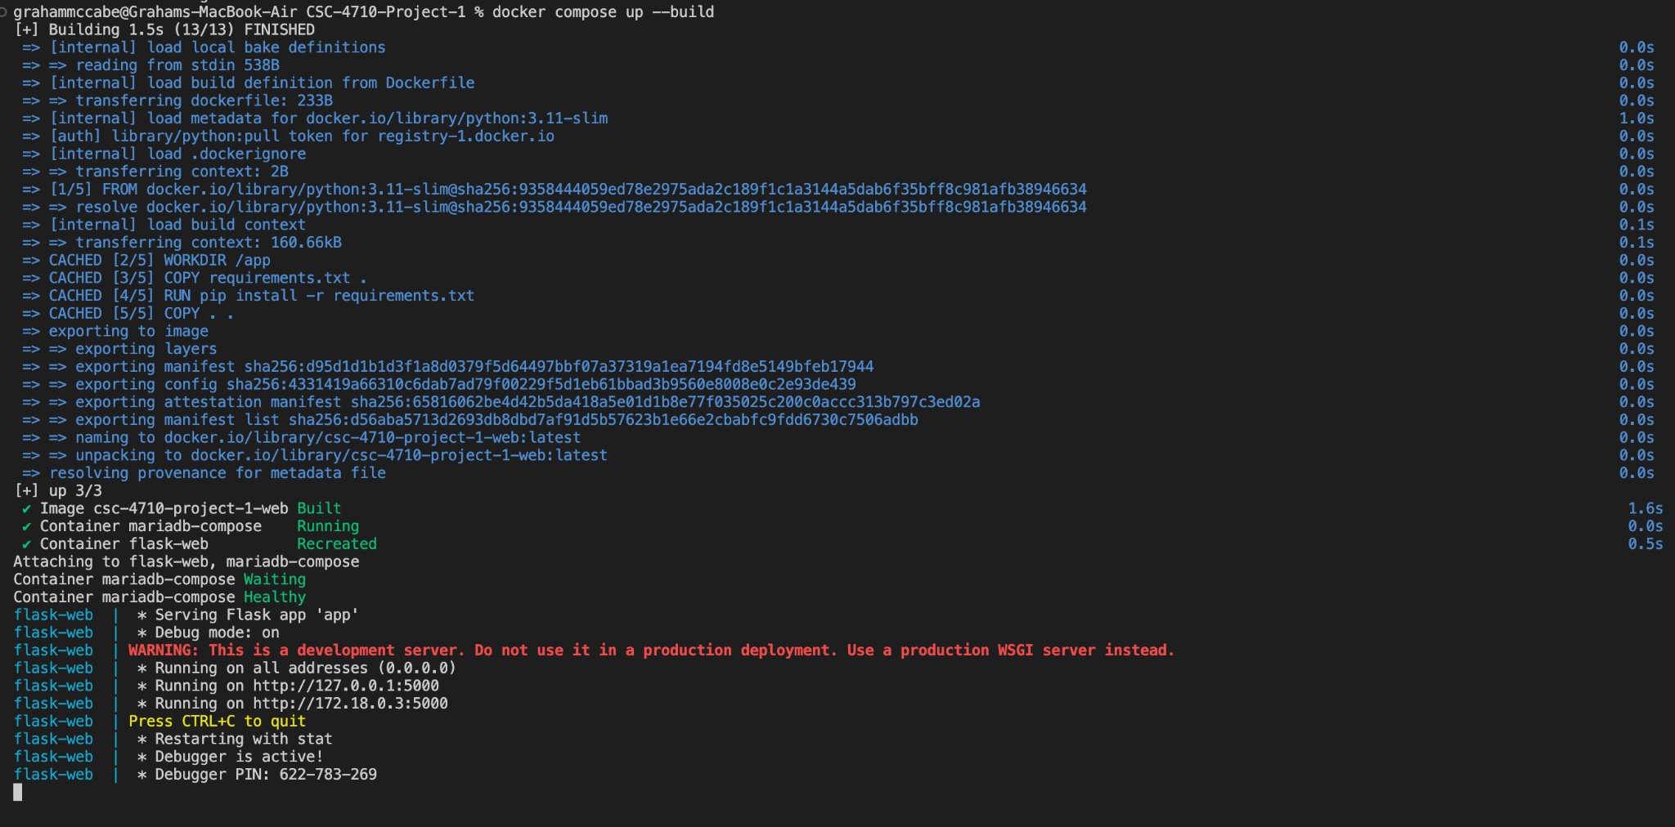

Figure 3: Command Line

Step 4: Accessing the System
- Open any web browser on your device, such as Google Chrome, Microsoft Edge, or Firefox.
- In the address bar at the top of the browser, type the following address and Press Enter: http://localhost:5001
- The Panther Cloud Air system will now load and is ready to use.

Employee User Guide

Overview
The Overview tab is the site’s home screen of the employee portal. The 3 cards on the overhead menu show the following:
- Flight Search
- Manage Bookings
- Live Status
The origin, destination, date, and number of passengers are displayed below when an employee searches for flights. The route overview is shown below. Located at the very bottom is information regarding various flight alerts.
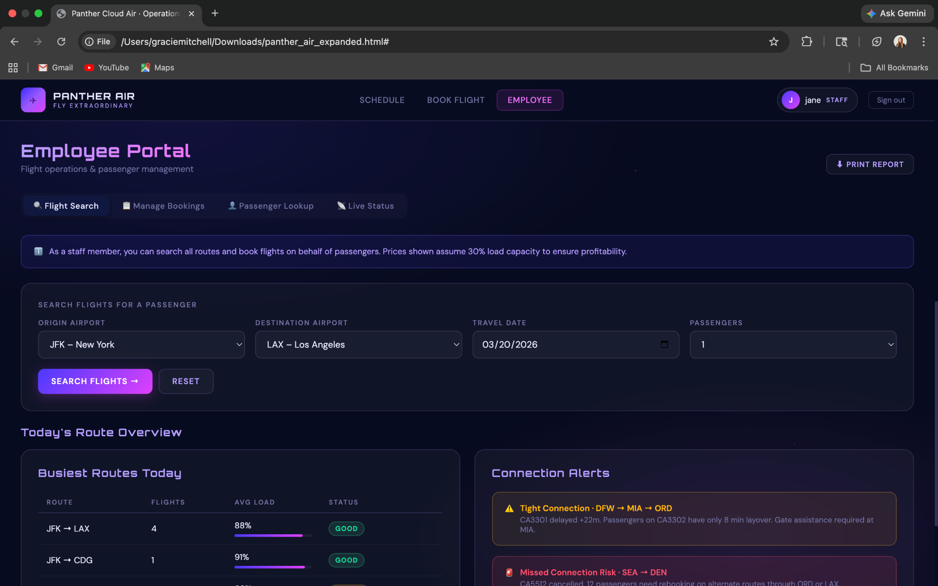

Figure 4: Employee Overview

Schedule
The tab for Schedule consists of different inputs to pick the origin, destination, date, and status for the different flights. Below that are the flights matching the information with the following:
- Flight
- From
- To
- Departure
- Arrival
- Aircraft
- Gate
- Load
- Status

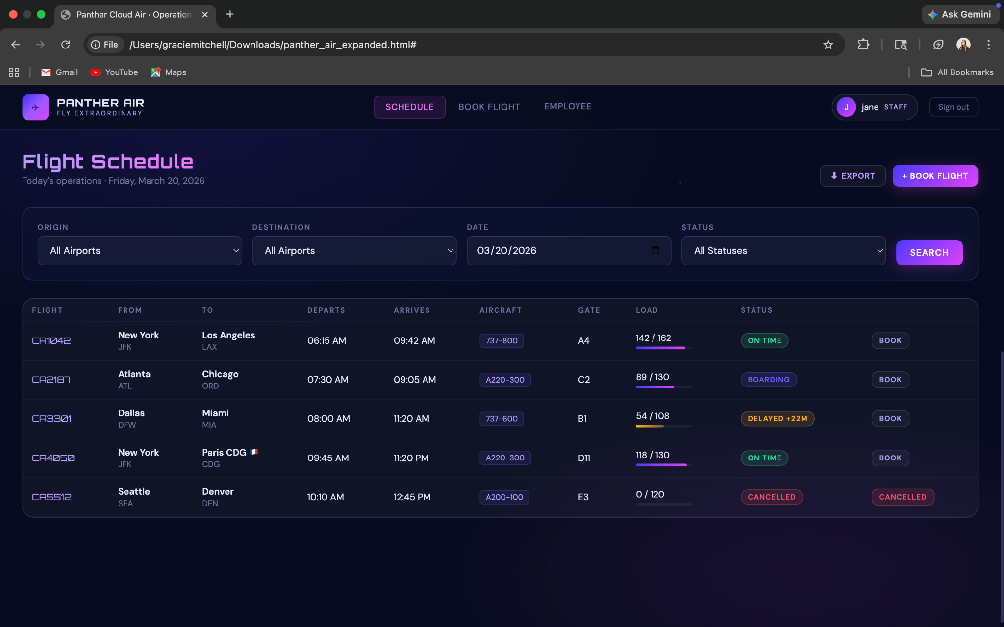

Figure 5: Schedule

Book Flight
When the employee navigates to book a flight they will be brought to a page where at the very top shows the process status of searching, selecting, confirming, and completion. The employee will have the option to pick the departure city, arrival city, depart date, return date, and passenger amount. Below this it will show the available flights fitting the requirements including the prices for the ticket and the status of the specific flight. Once a flight is selected it will then bring you to a page describing the flight summary, passenger information, and price breakdown. Once booking, the system will give you a confirmation screen and a booking reference.
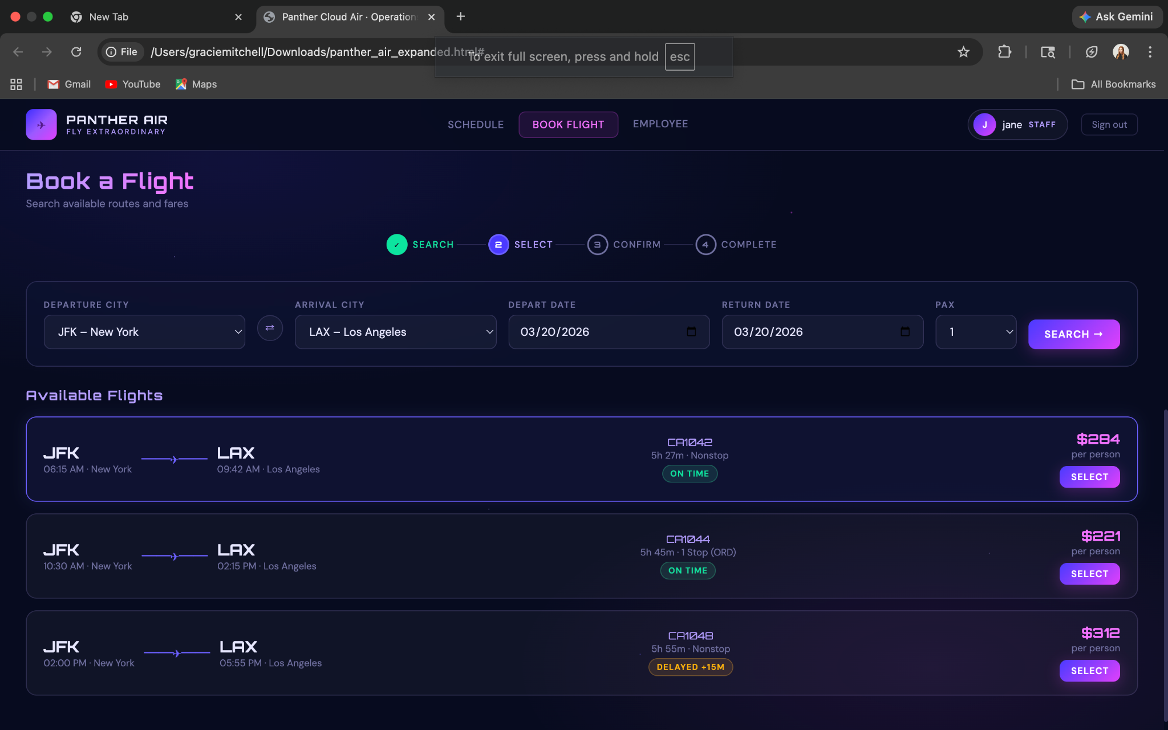

Figure 6: Booking
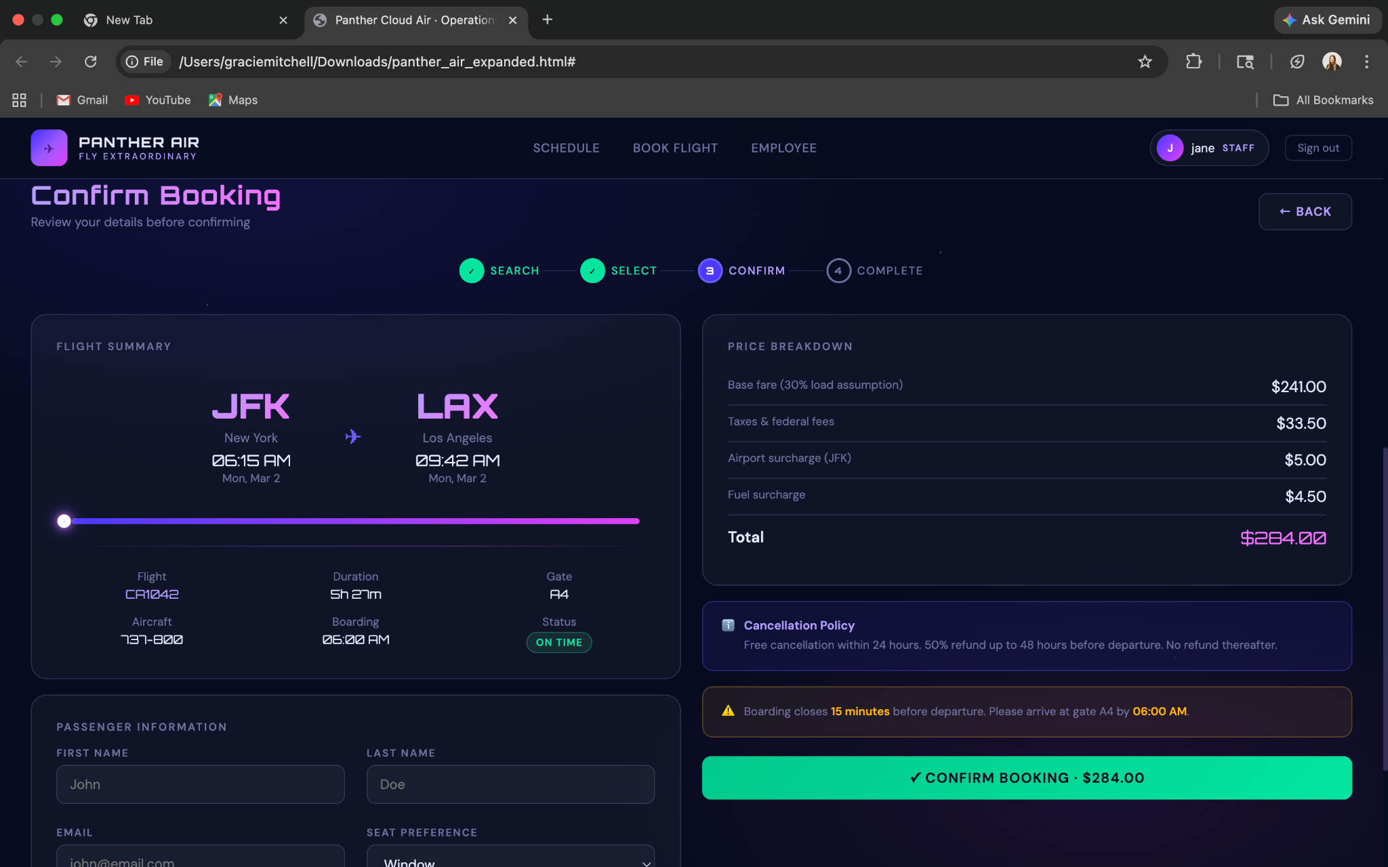

Figure 7: Selection

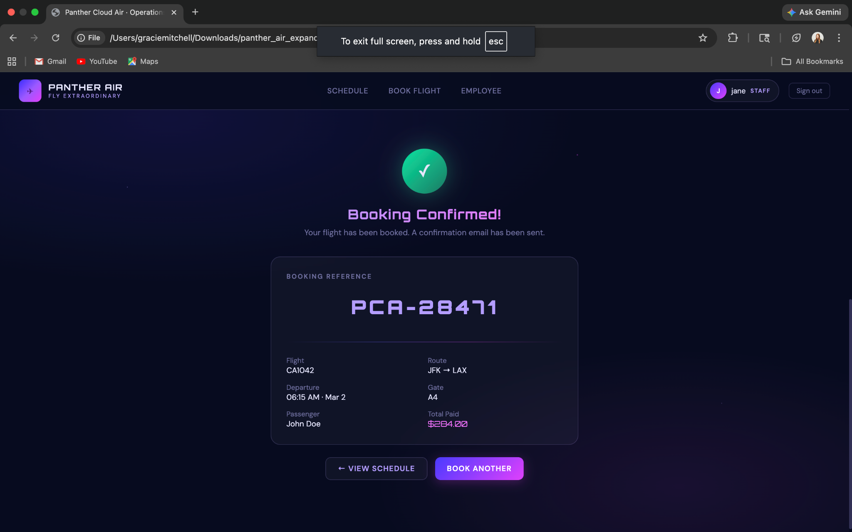

Figure 8: Confirmation

Administrator User Guide

Overview
The Overview tab is the site’s home screen. The six cards on the overhead menu show the following:
- Fleet size
- Flights today
- Passengers today
- Today’s revenue
- On-time rate
- Aircraft currently
Below that, a 14-day profit/loss bar shows which simulation days were profitable (those will be in green) and which were at a loss (those will be in red). To the right of this, there is a cost breakdown of all major expenses:

Cost Item | Overview
Fuel Costs | US $6.19/gallon fixed-price
Aircraft Leasing | Monthly lease per aircraft type:  $245k (737-600)  $270k (737-800)  $192k (A200-100)  $228k (A220-300)
Landing Fees (in the US) | $2,000 per takeoff and landing at each US airport
Paris CDG Fees | €2,100 per takeoff/landing, billed in euros at end-of-month exchange rate
Maintenance | Performed at hub airports only. Required every 200 flight hours, takes 1.5 days, max 3 aircraft per hub simultaneously

Table 1: Cost Overview

Any active simulation alerts, whether that be grounding due to weather or other situations, will be at the bottom of the page.

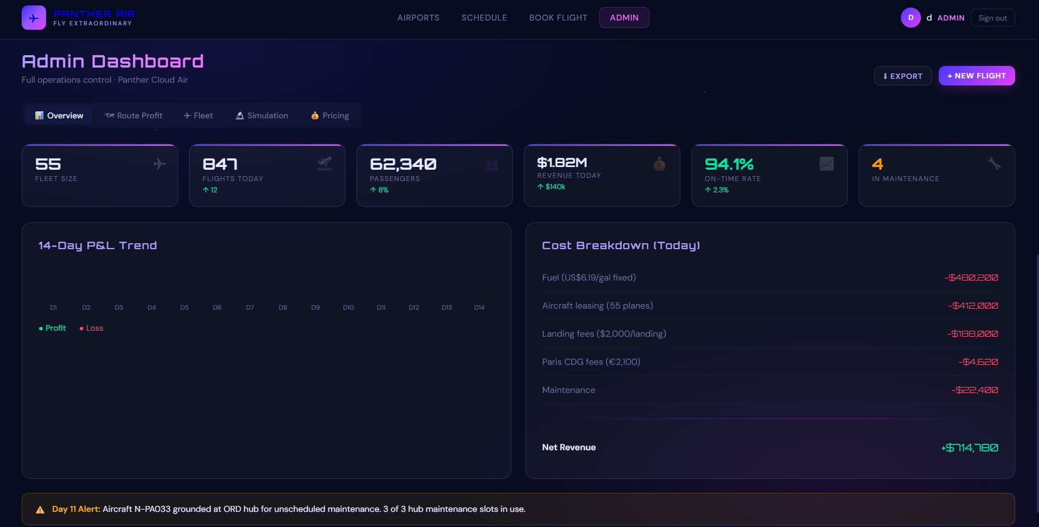

Figure 9: Admin Overview

Route Profit
This tab shows the profitability of every route flown by Panther Cloud Air. A filter is available to narrow down by hub and route to see which are the most profitable or which lose the most money. There is also a summary which displays the total profit and loss across all routes

The main table has:
- Every route
  - Distance
  - Current load %
  - Revenue
  - Fuel costs
  - Landing fees
  - Net profit or deficit
For every flight, the user will be able to look into the details of it. Clicking this opens a module with the full route analysis including distance, flight heading, wind adjustment (westbound flights take 4.5% longer; eastbound 4.5% less), cruising altitude, fuel consumption, and the breakeven passenger count at 30% load.

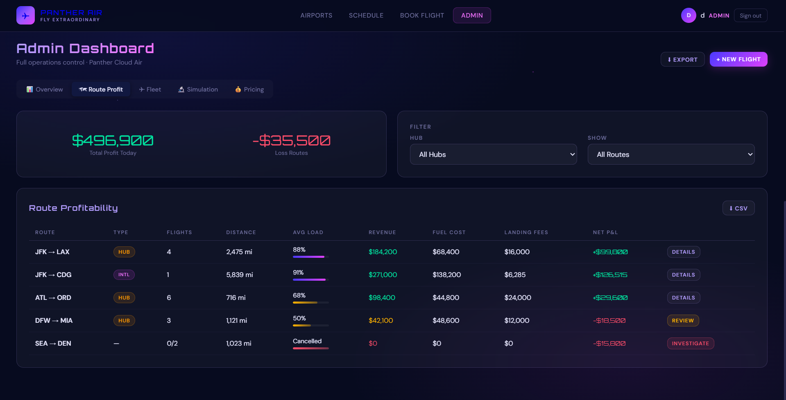

Figure 10: Route Profit

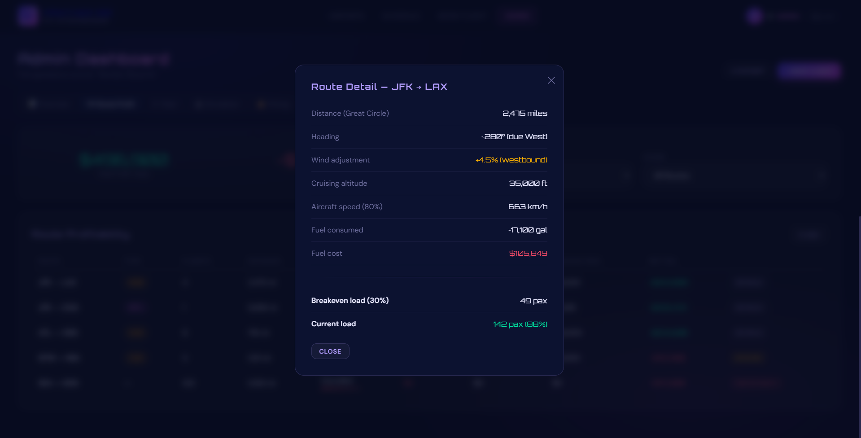

Figure 11: Route Detail

Fleet
The Fleet tab shows all 56 leased aircraft and their current operational status.

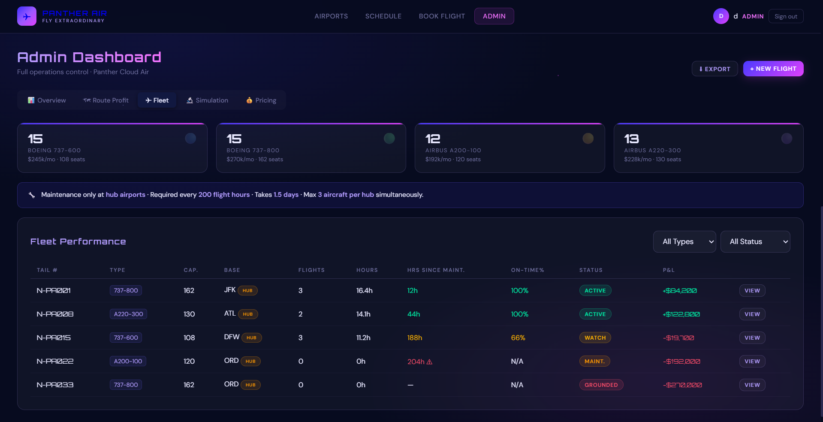

Figure 12: Admin Fleet Page

Fleet Summary Cards
Four cards at the top show the count, seat capacity, and monthly lease cost for each aircraft type in the fleet.

Fleet Performance Table
Each row represents one aircraft. Key columns to monitor:

Fleet Columns | Overview
Hours Since Maintenance | Hours flown since last maintenance. Turns orange at 180h as a warning. Turns red and shows a warning icon at 200h
On Time % | On-Time % Percentage of this aircraft's departures that left on schedule. Values below 80% indicate a reliability concern.
Status | Active (green), Watch (amber — approaching maintenance), Maintenance (orange — currently at hub), or Grounded (red — taken out of service).
P&L | Net profit or deficit for this aircraft today. An aircraft in maintenance will show a negative figure equal to its daily lease cost with no revenue.

Table 2: Fleet Column Table
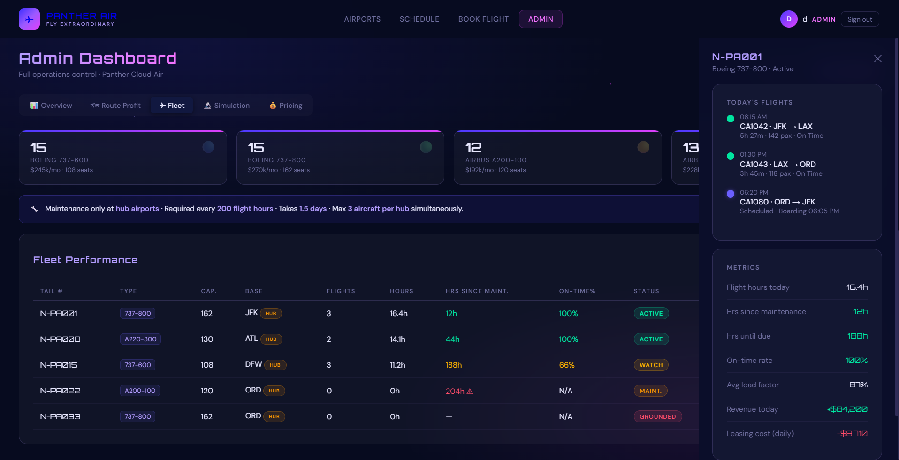

Figure 13: Fleet Detail View

Aircraft Detail Panel
Click View on any aircraft row to open the detail panel on the right side of the screen. The panel shows the aircraft's full flight history for the day as a timeline. The completed legs are marked with a green checkmark, the active legs in purple, and upcoming legs are in grey. Key metrics are below the timeline.

Simulation
This controls the 14-day operational simulation. The simulation runs one day at a time, applying a challenge for that day to all 195+ flights in the network plan.
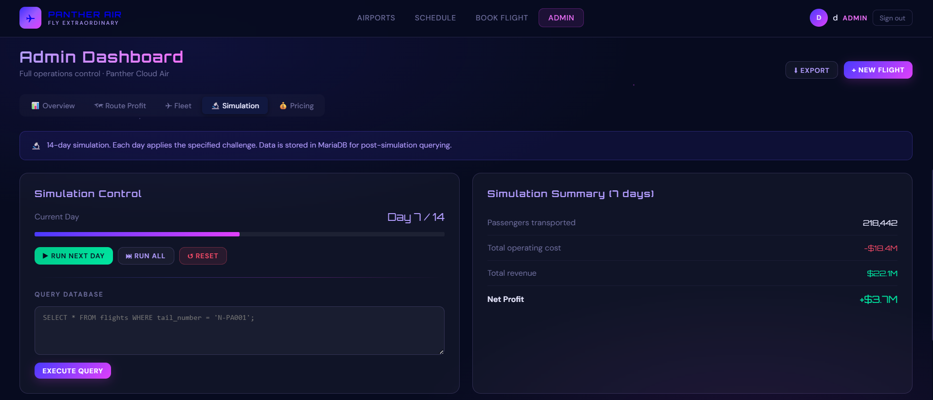

Figure 14: Simulation Control

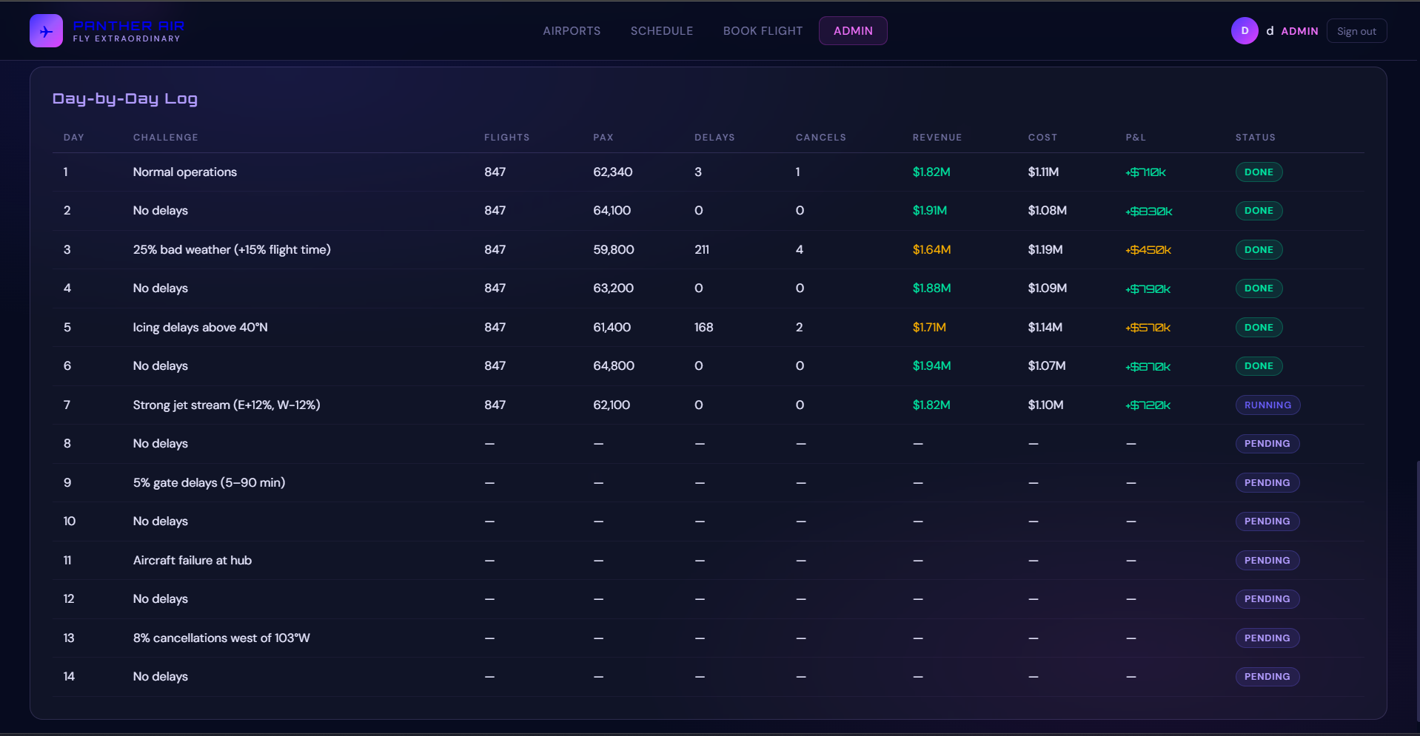

Figure 15: Simulation Days

Running the Simulation
- Click Run Next Day to advance by one day. The progress bar and day counter update.
- Click Run All Remaining to complete all pending days in sequence.
- Click Reset to clear all results and restart from Day 1

Simulation Report
After the simulation completes, the Summary panel shows total passengers transported, total operating cost, total revenue, and net profit or loss across all 14 days. The day-by-day log table records the same figures per day for detailed analysis

Pricing
The Pricing tab controls the profit applied to all airfares, and shows the parameters used for the Paris CDG route.

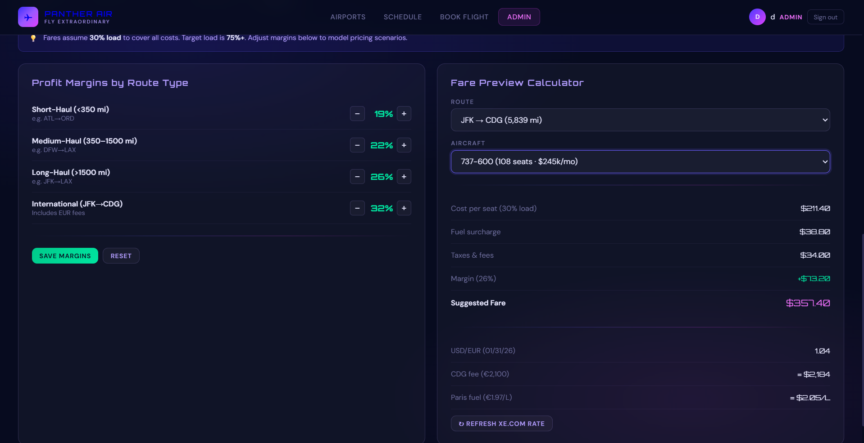

Figure 16: Pricing Tab

Profit Margins
Fares are calculated assuming a 30% load factor. This makes sure all costs are covered on the least popular flights. The target occupancy is 75% or above, which creates a healthy profit at these margins. Use the + and − buttons to adjust the margin for each route category

Route Category | Set Margin | Example Routes
Short-Haul (< 350 mi) | 18% | ATL - ORD
Medium-Haul (350–1,500 mi) | 22% | DWF - LAX
Long-Haul (> 1,500 mi) | 26% | JFK - LAX
International (JFK → CDG) | 32% | JFK - CDG

Table 3: Pricing Margins

Click “Save Margins” to apply changes. Click “Reset” to restore all values to the defaults above

Class Multipliers
The cabin class multipliers are fixed. Economy fares use a base fare. Business class fares are 2.2 times the base fare. First class fares are 4 times the base fare.

Administrator User Guide
The table below shows which features each role can access in the portal.

Feature | Employee | Admin
View flight schedule | Yes | Yes
Search flights | Yes | Yes
Book flights | Yes | Yes
View connections | Yes | Yes
Live flight tracker | Yes | Yes
Route profit reports | No | Yes
Fleet managements | No | Yes
Simulation controls and queries | No | Yes
Pricing & margin adjusting | No | Yes

Table 4: Employee vs Admin Features

